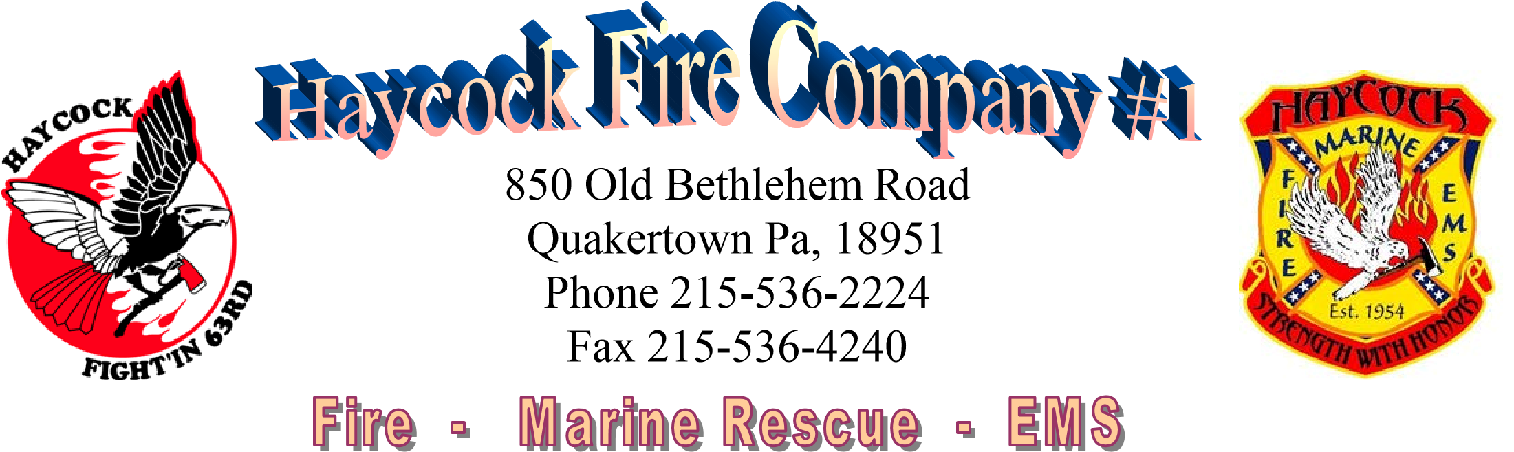

**APPLICATION AND INFORMATION**

**HOLIDAY VENDOR AND CRAFT SHOPPE**

**SATURDAY, NOVEMBER 23, 2024 9 AM-3 PM**

HAYCOCK TOWNSHIP COMMUNITY CENTER

1014 OLD BETHLEHEM ROAD, QUAKERTOWN, PA 18951

Please mail your applications and payment to HAYCOCK FIRE COMPANY, 850 Old Bethlehem Road, Quakertown, PA 18951. Email Questions to [sbarnes@haycockfire.org](mailto:sbarnes@haycockfire.org)

**FEES: $50 per SPACE PLUS** **A DONATION OF 1 ITEM (YOUR CRAFT OR SALE ITEM)** to the Haycock Fire Company Holiday Vendor/Craft Raffle. Donated items collected at check-in/set up please.

**SPACE ASSIGNMENTS:** Spaces will be assigned at check-in. Please note that your ‘booth’ **MUST** fit within the assigned space. Spaces allow for an 8” long table with space to side and behind. Please note on your application booth layout/space requirement to allow for show layout.

**SET UP:** Friday evening set up 6-8 PM and beginning Saturday morning at 7 AM. You must be set up by 9 AM.

**PAYMENT ACCEPTED FOR SPACE(S):** Checks or money orders made payable to Haycock Fire Company. Mail payment and application to Haycock Fire Company, 850 Old Bethlehem Road, Quakertown, PA 18951. **Deadline is NOVEMBER 9, 2024**. Space is limited. **Space given in order of application/payment received**. Confirmation will be made via email.

**VENDOR SALES:** Vendors are responsible for their own sales. Vendors understand that the Haycock Fire Company is hosting the event and holds no responsibility or guarantee of sales. The Haycock Fire Company is not responsible for any damage or loss of property. It is the responsibility of the vendor to leave their area clean.

**FOOD:** Haycock Fire Company, as a fundraiser, will be selling food at a canteen set up at the event.

**PROCEEDS BENEFIT HAYCOCK FIRE COMPANY**

HAYCOCK FIRE COMPANY

VENDOR/CRAFT SHOPPE APPLICATION

CONTACT INFORMATION-PLEASE PRINT CLEARLY

NAME_________________________________________________

BUSINESS NAME (IF APPLICABLE)___________________________________________

ADDRESS______________________________________________

PHONE________________________EMAIL___________________

WEBSITE (IF

APPLICABLE)___________________________________________

WHAT YOU WILL BE SELLING?______________________________________________

SPACE REQUIREMENTS/COMMENTS_____________________________

*DIAGRAM/PHOTO OF YOUR BOOTH SET UP WOULD BE HELPFUL FOR THOSE REQUIRING SPECIAL CONSIDERATIONS.

WILL YOU NEED A TABLE? YES NO (LIMITED NUMBER AVAILABLE)

WILL YOU NEED ELECTRICITY? YES NO (LIMITED ACCESS AND NOT GUARANTEED)

EMAIL QUESTIONS: [SBARNES@HAYCOCKFIRE.ORG](mailto:SBARNES@HAYCOCKFIRE.ORG)

DEADLINE-- NOVEMBER 9, 2024